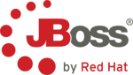

Lab 9. Accessing Data Federation Layer using Odata
The Open Data Protocol (OData) is a Web protocol for querying and updating data that provides a way to unlock your data and free it from silos that exist in applications today. OData does this by applying and building upon Web technologies such as HTTP, Atom Publishing Protocol (AtomPub) and JSON to provide access to information from a variety of applications, services, and stores. OData is used to expose and access information from a variety of sources including, but not limited to, relational databases, file systems, content management systems and traditional Web sites.
OData is consistent with the way the Web works, it makes a deep commitment to URIs for resource identification and commits to an HTTP-based, uniform interface for interacting with those resources (just like the Web). This allows OData to enable a new level of data integration and interoperability across a broad range of clients, servers, services, and tools.
For more information on OData see http://www.odata.org
9.1 How to access the data
When you have successfully deployed the Financials VDB into the JBoss Data Virtualization server, the OData protocol support is implicitly provided by the JBoss Data Virtualization server without any further configuration.
Now, open up a browser and point it to the following URL: http://localhost:8080/odata/Financials.1/All_Customers.customer.
If you are requested to type in a username/password enter user/user. This is similar to making a JDBC/ODBC connection and issuing a SQL call as SELECT * FROM All_Customers.customer;
The returned results from OData query can be in Atom/AtomPub XML format or JSON format. By default AtomPub based XML result is returned as shown below.
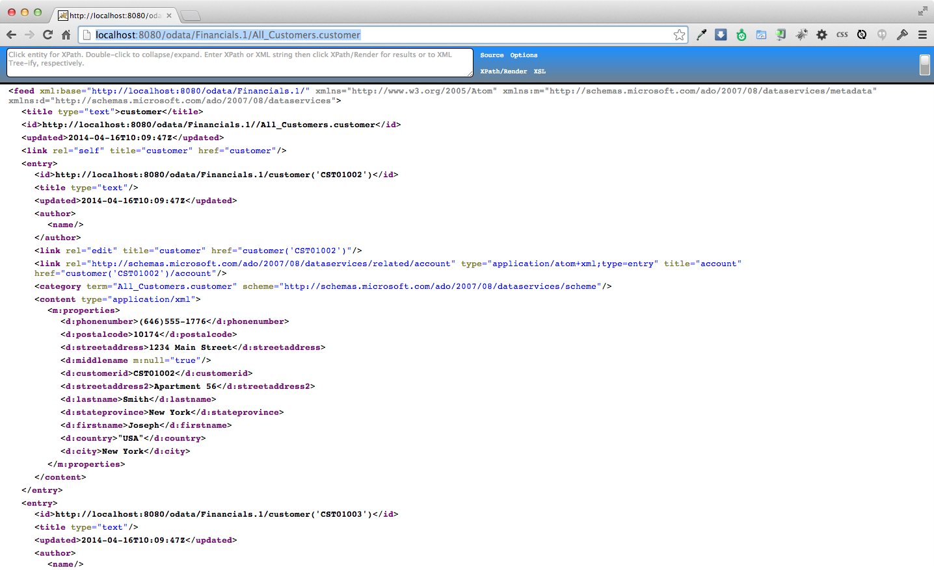
To return the results in JSON format use the following URL as shown below:
http://localhost:8080/odata/Financials.1/All_Customers.customer?$format=json
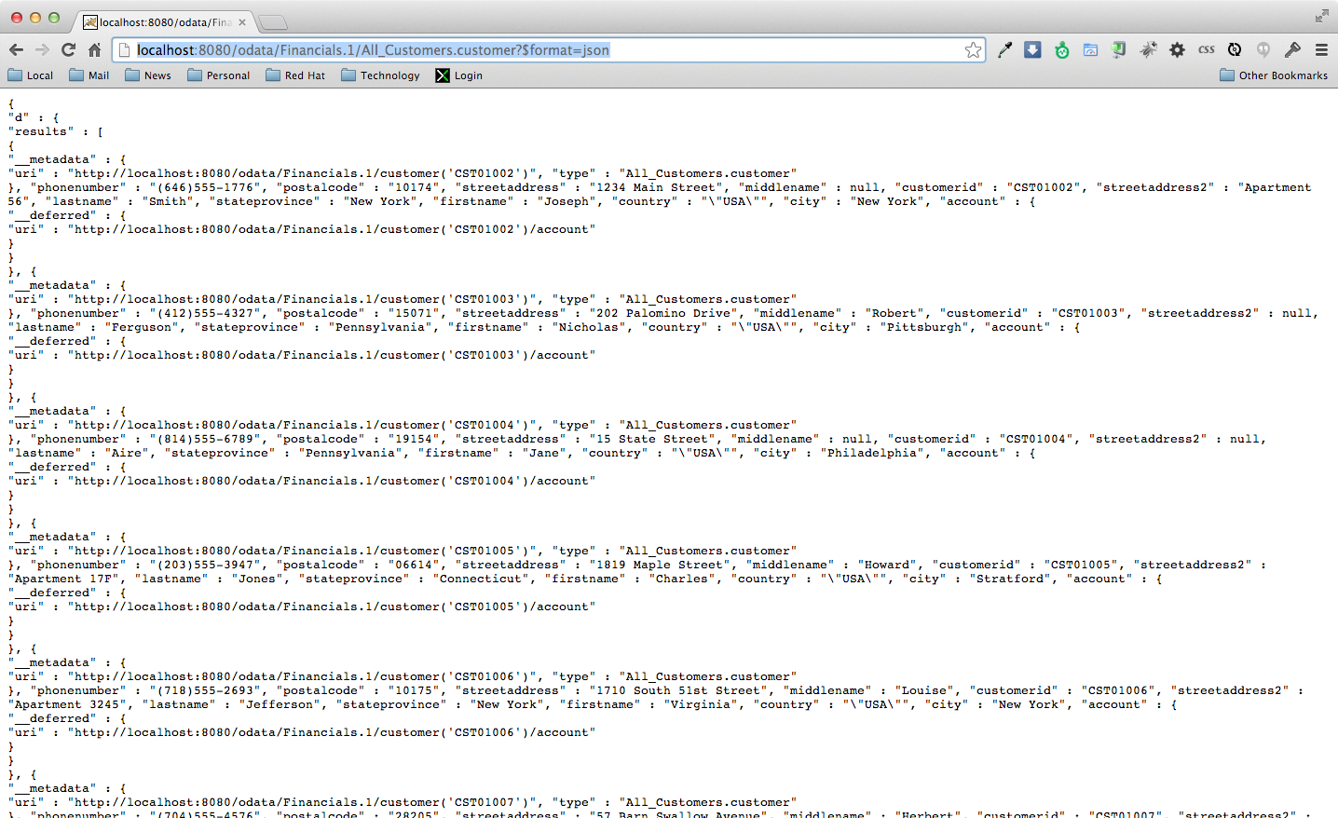

9.2 How to query the data
To search for customer with customerid='CST01033' which is the SQL equivalent of
SELECT * FROM All_Customers.customer where customerid='CST01033';
use following URL and it should return the results shown below:
http://localhost:8080/odata/Financials.1/customer('CST01033')
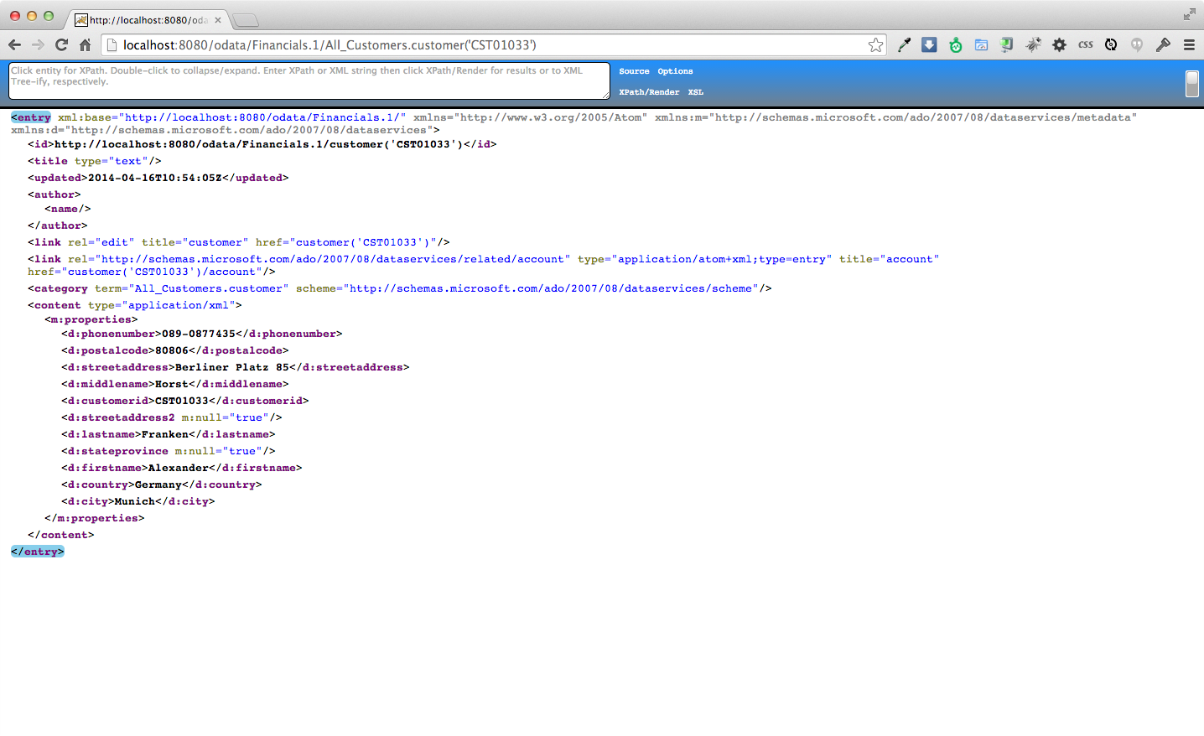

Another way to query the data is to use the OData filter system query option using $filter in the URL. The $filter system query option allows clients to filter the set of resources that are addressed by a request URL. $filter specifies conditions that MUST be met by a resource for it to be returned in the set of matching resources.
To search customers from the USA try following URL:
http://localhost:8080/odata/Financials.1/All_Customers.customer?$filter=country eq 'USA'
and this should return the results as shown below.
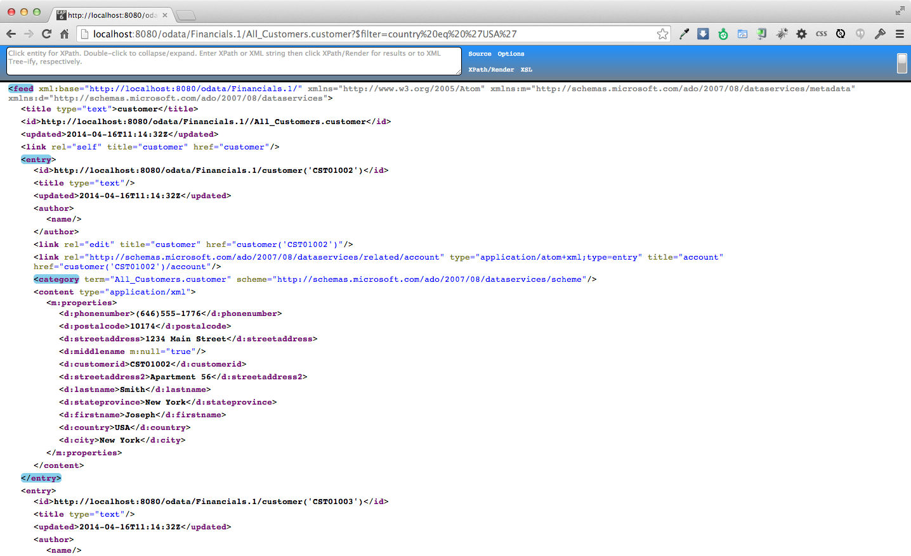
Congratulations, you have completed Lab #9.

